
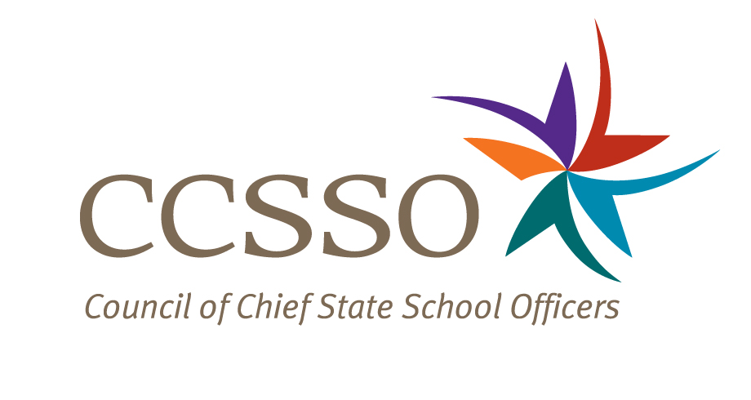

National Network of State School Improvement Leaders
Webinar – Supporting Systemic Change in High Schools

Attendee Online Registration*: https://ccsso.webex.com/ccsso/onstage/g.php?t=a&d=712629691
Call-in toll-free number (US/Canada)*: 866-469-3239
Event Number: 712 629 691
Start Time: 3:00 PM ET/2:00 CT/12:00 PT

* Notice for Participants & Panelists: Please login first before calling. When signing on online, please use your state abbreviation or organization’s acronym before typing your name.
(ex: MA-Horace Mann)

Agenda

Objectives
Introduce the Webex format & the day’s webinar session and presenters
Present the high school SIG landscape across the nation
Describe the state and local context unique to Arizona and Pima Prevention Partnership, including how the SIG awards align with other high school renewal efforts underway in the state and school district
Share tools and processes they are using in the selection of School Improvement Grant (SIG) award recipients and in tracking the implementation of the SIG initiative
Discuss how the Arizona State Department of Education and the school districts (particularly Pima Prevention Partnership) are progressing in changing their ways of doing business
Share lessons learned and identify issues and needs
Discuss questions raised by attendees

Thursday, October 28, 2010
3:00-3:05 | WebEx Orientation and Introductions (Nina de las Alas and Susan Hanes)  See posted description for the purpose of the Network, brief description of the webinar and presenters’ biographies.
3:05-3:10 | National High School SIG Overview (Joseph Harris, National High School Center at the American Institutes for Research)  - What are the some of the preliminary findings coming out of the reviews of the SEA applications and the winning LEA applications?
3:10-3:40 | Arizona and Pima Partnership: A State and Local District Perspective (Angela Denning, Arizona Department of Education, Lisa Long, Pima Partnership High School and Mike Dunbar, Pima Prevention Partnership)  - Introductions  - What is the state context? Local context?  - What tools, processes, and strategies did Arizona Department of Education (ADE) use to identify SIG-eligible LEAs and schools?  - Did ADE require high schools to adopt any specific strategies as part of the LEA SIG plans?  - How do the SIG awards align with other existing high school initiatives in the state? In the
district?
- What supports/assistance does ADE provide to SIG districts with high schools? How does ADE differentiate the assistance to districts and schools, including non-SIG districts and non-SIG schools? What supports/assistance is the Pima Partnership providing? How does the Pima Partnership differentiate its assistance?
- How are ADE and Pima Partnership changing the way they do business? What leading indicators are both agencies using to track progress?
- What issues does ADE need addressing? And for Pima Partnership? What lessons learned could both agencies share?
3:40-3:55 | Q & A from attendees  [Please type in your questions in Q & A section of WebEx or use the raise-your–hand icon].
3:55- 4:00 | Housekeeping (Nina de las Alas)  - Recording of Session, PPT slides, and additional resources  - Availability of resources and continuation of the conversation via Network Community site (http://communities.ccsso.org/group/NNSSIL)  - Questions? Send to Susan Hanes, shanes@centerii.org  - Post-session survey
4:00 | Adjourn

