
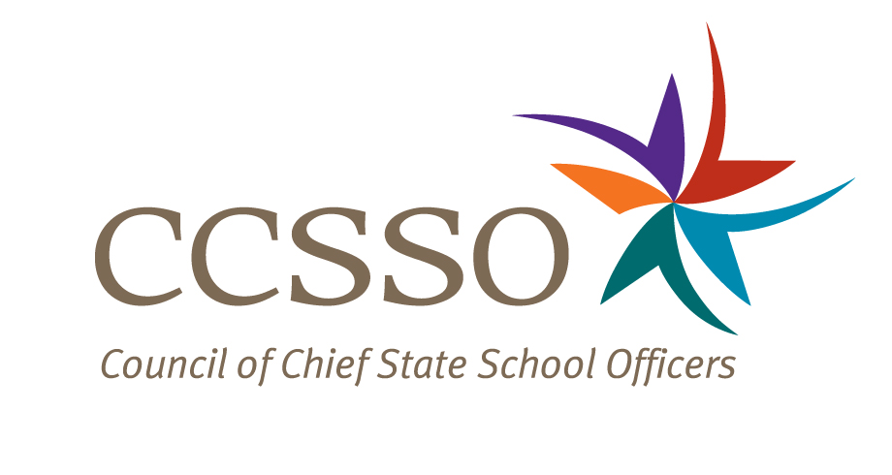

National Network of State School Improvement Leaders
Webinar – Supporting Rural Schools and Districts

Attendee Online Registration*: https://ccsso.webex.com/ccsso/onstage/g.php?t=a&d=710725141
Call-in toll-free number (US/Canada)*: 866-469-3239
Event Number: 710 725 141
Start Time: 1:00 PM ET/12:00 CT/10:00 PT

* Notice for Participants & Panelists: Please login first before calling. When signing on online, please use your state abbreviation or organization’s acronym before typing your name.
(ex: MA-Horace Mann)

Agenda

Objectives
Introduce the Webex format & the day’s webinar session and presenters
Present North and South Carolina’s approaches to provide quality education to schools and districts in rural setting.
Discuss questions raised by attendees

Friday, July 23, 2010
1:00-1:05 | WebEx Orientation and Introductions (Nina de las Alas and Susan Hanes)  See attached description of the purpose of the Network, brief description of the webinar and presenter biography.
1:05-1:15 | Overview (Andrea Browning, American Youth Policy Forum)  - What has been learned from the field about the unique challenges and opportunities for teaching and learning in rural settings?  - Highlights from AYPF’s field trip in February 2010
1:15-1:25 | North Carolina (Brian Setser, CEO, North Carolina Virtual Public School)  - What are the unique needs of rural students in North Carolina?  - How does North Carolina meet those needs? What strategies are used?  - How are these strategies designed, funded, implemented and sustained?
1:25-1:35 | South Carolina (Mark Bounds, Deputy Superintendent, Office of School Leadership)  - What are the unique needs of rural students in South Carolina?  - How does South Carolina meet those needs? What strategies are used?  - How are these strategies designed, funded, implemented and sustained?
1:35-1:55 | Q & A from attendees  [Please type in your questions in Q & A section of WebEx or use the raise-your–hand icon].
1:55- 2:00 | Housekeeping (Nina de las Alas)  - Recording of Session, PPT slides, and additional resources  - Reminder: LEA SIG Online Survey  - Availability of resources and continuation of the conversation via Network Community site (http://communities.ccsso.org/group/NNSSIL)  - Questions? Send to Susan Hanes, shanes@centerii.org  - Post-session survey
2:00 | Adjourn

