
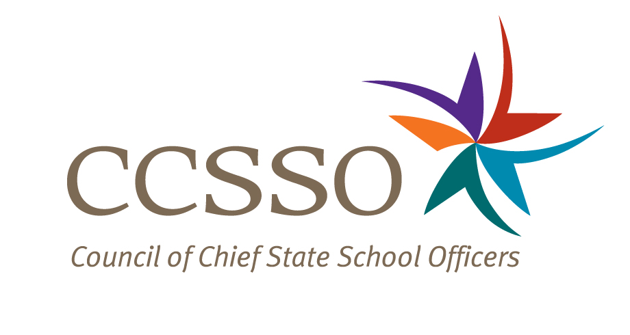

National Network of State School Improvement Leaders
Webinar – Training Models Geared for Rapid
Improvement Initiatives

Attendee Online Registration*: https://ccsso.webex.com/ccsso/onstage/g.php?t=a&d=714292652
Call-in toll-free number (US/Canada)*: 866-469-3239
Event Number: 714 292 652
Start Time: 3:00 PM ET/2:00 CT/12:00 PT

* Notice for Participants & Panelists: Please login first before calling. When signing on online, please use your state abbreviation or organization’s acronym before typing your name.
(ex: MA-Horace Mann)

Agenda

Objectives
Introduce the Webex format & the day’s webinar session and presenters
Present Louisiana’s and Chicago’s turnaround training models
Discuss questions raised by attendees

Wednesday, June 16, 2010
3:00-3:05 | WebEx Orientation and Introductions (Nina de las Alas and Susan Hanes)  See attached description of the purpose of the Network, brief description of the webinar and presenter biography.
3:05-3:23 | Louisiana (Sheila Guidry)  - Overview and context for the Louisiana School Turnaround Specialist Program  - Evolution from a pilot program to statewide endeavor: train the trainers  - Program description: costs, funding sources, selection and recruitment, module overview, and performance metrics  - Early successes and lessons learned  - Sustainability
3:23-3:41 | Chicago (Don Fraynd and Randel Josserand)  - Video: Overview and context with stakeholder perspectives  - History on the formation of the Office of School Turnaround  - Model description: costs, funding sources, phases of implementation, and performance metrics  - Early successes and lessons learned  - Sustainability
3:41-3:55 | Q & A from attendees  [Please type in your questions in Q & A section of WebEx or use the raise-your–hand icon].
3:55- 4:00 | Housekeeping (Nina de las Alas)  - Recording of Session, PPT slides, and additional resources  - Reminder: LEA SIG Online Survey  - Availability of resources and continuation of the conversation via Network Community site (http://communities.ccsso.org/group/NNSSIL)  - Questions? Send to Susan Hanes, shanes@centerii.org  - Post-session survey
4:00 | Adjourn

