
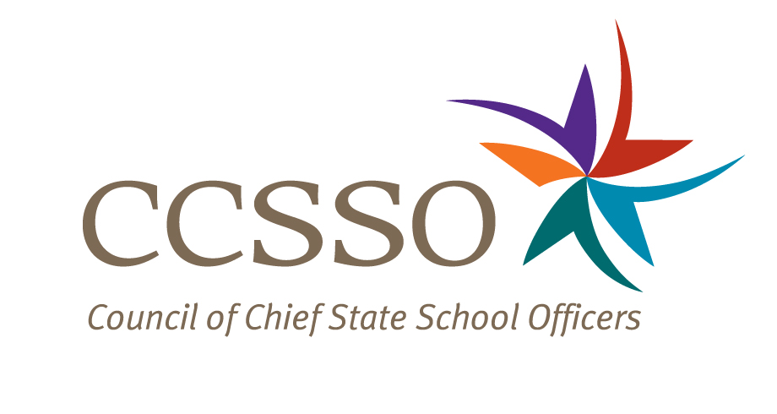

National Network of State School Improvement Leaders
Webinar – Mechanisms and Indicators for Determining Progress and SIG Renewal

Attendee Online Registration*: https://ccsso.webex.com/ccsso/onstage/g.php?t=a&d=714173143
Call-in toll-free number (US/Canada)*: 866-469-3239
Event Number: 714 173 143
Start Time: 3:00 PM ET/2:00 CT/12:00 PT

* Notice for Participants & Panelists: Please login first before calling. When signing on online, please use your state abbreviation or organization’s acronym before typing your name.
(ex: MA-Horace Mann)

Agenda

Objectives
Introduce the WebEx format & the day’s webinar session and presenters
Present Arkansas’ efforts in determining progress and renewal
Present Mississippi’s efforts in determining progress and renewal
Discuss questions raised by attendees

Wednesday, April 18, 2012
3:00-3:10 | WebEx Orientation and Introductions (Nina de las Alas and Susan Hanes)  Go to www.centerii.org/leaders for complete descriptions of the Network, today’s webinar and presenters’ biographies.
3:10-3:27 | Arkansas (Jayne Green, SIG Program Administrator, Office of Federal Programs and Kyron Jones, SIG Site Director, Office of Federal Programs )  - Identify tools and resources the state education agency (SEA) uses to monitor SIG schools  - Recount lessons learned as the SEAs’ policies and practices have evolved  - Share best practices  - Discuss how Arkansas determines progress and makes decisions on renewal  - Highlight ongoing issues, challenges, and points to consider
3:27-3:42 | Mississippi (Kim Benton, Bureau Manager in the Office of School Recovery)  - Identify tools and resources the state education agency (SEA) uses to monitor SIG schools  - Recount lessons learned as the SEAs’ policies and practices have evolved  - Share best practices  - Discuss how Mississippi determines progress and makes decisions on renewal  - Highlight ongoing issues, challenges, and points to consider
3:42-3:57 | Q & A from attendees  [Please type in your questions in Q & A section of WebEx or use the raise-your–hand icon].
3:57- 4:00 | Housekeeping (Nina de las Alas)  - Recording of Session, PPT slides, and additional resources  - Reminder: Feedback and Follow-Up Session  - Questions? Send to Susan Hanes, shanes@centerii.org
4:00 | Adjourn

