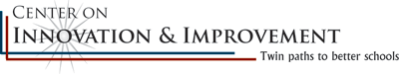
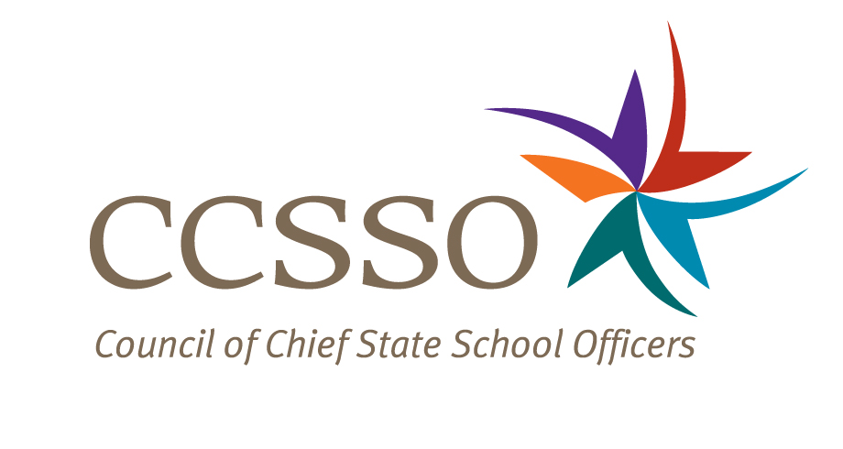

National Network of State School Improvement Leaders
Webinar – Monitoring LEA Implementation of School Improvement Interventions: Moving Beyond Compliance

Attendee Online Registration*:
https://ccsso.webex.com/ccsso/onstage/g.php?t=a&d=718514267
Call-in toll-free number (US/Canada)*: 866-469-3239
Event Number: 718 514 267
Start Time: 4:00 PM ET/3:00 CT/1:00 PT

* Notice for Participants & Panelists: Please login first before calling. When signing on online, please use your state abbreviation or organization’s acronym before typing your name.
(ex: MA-Horace Mann)

Agenda

Objectives
Introduce the Webex format & the day’s webinar session and presenters
Present Minnesota’s and New Jersey’s approaches to monitoring
Discuss questions raised by attendees

Wednesday, April 21, 2010
4:00-4:05 | WebEx Orientation and Introductions (Nina de las Alas and Susan Hanes)  See attached description of the purpose of the Network, brief description of the webinar and presenter biography.
4:05-4:23 | Minnesota (Pat King and Jonathan Luknic)  - Minnesota’s School Improvement Grants in brief  - What performance indicators is the state agency focusing on?  - What are the agency’s monitoring policies, structures, and practices?  - How is the agency using these monitoring policies, structures and practices to move beyond federal reporting requirements?  - How is the agency using these monitoring policies, structures and practices to build sustainable capacity for change within the LEAs?
4:23-4:41 | New Jersey (Suzanne Ochse and Pat Mitchell)  - New Jersey’s School Improvement Grants in brief  - What performance indicators is the state agency focusing on?  - What are the agency’s monitoring policies, structures, and practices?  - How is the agency using these monitoring policies, structures and practices to move beyond federal reporting requirements?  - How is the agency using these monitoring policies, structures and practices to build sustainable capacity for change within the LEAs?
4:41-4:55 | Q & A from attendees  [Please type in your questions in Q & A section of WebEx or use the raise-your–hand icon].
4:55- 5:00 | Housekeeping (Nina de las Alas)  - Recording of Session  - Profiles of state monitoring practices as found in approved SIG applications  - Availability of resources and continuation of the conversation via Network Community site (http://communities.ccsso.org/group/NNSSIL)  - Questions? Send to Susan Hanes, shanes@centerii.org  - Post-session survey
5:00 | Adjourn

