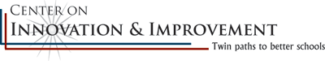
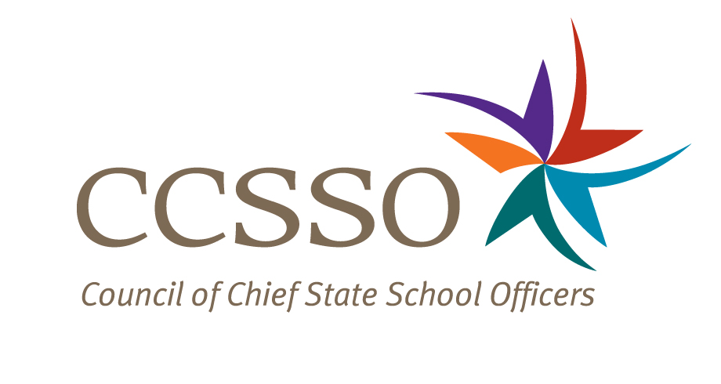

National Network of State School Improvement Leaders
Webinar – Lessons Learned from the First 20 Months of Implementing School Improvement Grants

Attendee Online Registration*: https://ccsso.webex.com/ccsso/onstage/g.php?t=a&d=717471212
Call-in toll-free number (US/Canada)*: 866-469-3239
Event Number: 717 471 212
Start Time: 3:00 PM ET/2:00 CT/12:00 PT

* Notice for Participants & Panelists: Please login first before calling. When signing on online, please use your state abbreviation or organization’s acronym before typing your name.
(ex: MA-Horace Mann)

Agenda

Objectives
Introduce the WebEx format & the day’s webinar session and presenters
Briefly present Fulcrum of Change study design and findings
Present lessons learned from Michigan and Oklahoma since the Fulcrum of Change report was published
Discuss questions raised by attendees

Wednesday, February 15, 2012
3:00-3:06 | WebEx Orientation and Introductions (Nina de las Alas and Susan Hanes)  Go to www.centerii.org/leaders for complete descriptions of the Network, today’s webinar and presenters’ biographies.
3:06-3:14 | Fulcrum of Change report (Sam Redding, Director, Center on Innovation and Improvement)  - Describe the scope of the study and identify the study questions  - Share emerging lessons and early indicators of positive change
3:14-3:24 | Michigan (Mark Coscarella, Assistant Director in the Office of Education Improvement and Innovation)  - Describe Michigan’s context for implementing the School Improvement Grants (SIG)  - Share information on how the state, district, school, and technical provider staff are doing business differently as a result of their school improvement work, particularly in organizational management, governance, and training  - Provide insights into the successes they have witnessed among the SIG and non-SIG fund-recipient schools and districts  - Discuss their continued concerns, issues and challenges, and  - Discuss future directions as result of what they have learned
3:24-3:44 | Oklahoma (Mary Colvin, Executive Director of School Support/School Improvement; Gina Scroggins, Director of SIG Turnaround Schools; Brian Staples, Principal, Frederick A. Douglass Middle and High School, Oklahoma City)  - Describe Oklahoma’s context for implementing the School Improvement Grants (SIG)  - Share information on how the state, district, school, and technical provider staff are doing business differently as a result of their school improvement work, particularly in organizational management, governance, and training  - Provide insights into the successes they have witnessed among the SIG and non-SIG fund-recipient schools and districts  - Discuss their continued concerns, issues and challenges, and  - Discuss future directions as result of what they have learned
3:44-3:55 | Q & A from attendees  [Please type in your questions in Q & A section of WebEx or use the raise-your–hand icon].
3:55- 4:00 | Housekeeping (Nina de las Alas)  - Recording of Session, PPT slides, and additional resources  - Reminder: Feedback and Follow-Up Session  - Questions? Send to Susan Hanes, shanes@centerii.org
4:00 | Adjourn

