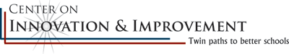
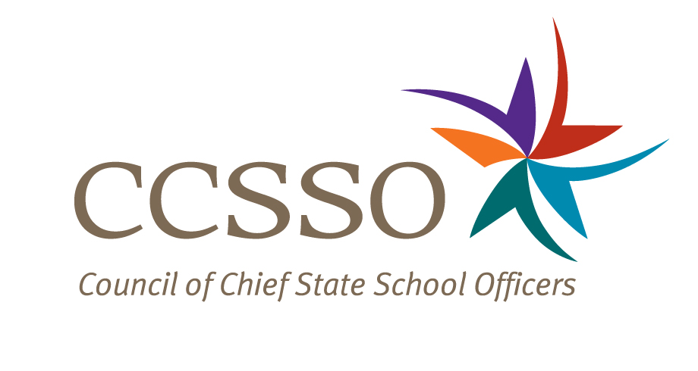

National Network of State School Improvement Leaders
Webinar – How SEAs’ Statewide Systems of Support (SSOS) Build Systemic Capacity for LEAs and Schools

Attendee Online Registration*: https://ccsso.webex.com/ccsso/onstage/g.php?t=a&d=716794915
Call-in toll-free number (US/Canada)*: 866-469-3239
Event Number: 716 794 915
Start Time: 3:00 PM ET/2:00 CT/12:00 PT

* Notice for Participants & Panelists: Please login first before calling. When signing on online, please use your state abbreviation or organization’s acronym before typing your name.
(ex: MA-Horace Mann)

Agenda

Objectives
Introduce the WebEx format & the day’s webinar session and presenters
Present Washington and Ohio’s approaches in statewide systems of support (SSOS) and the highlights from an upcoming CII report that examines nine states’ approaches to supporting dramatic school improvement
Discuss questions raised by attendees

Monday, June 27, 2011
3:00-3:06 | WebEx Orientation and Introductions (Nina de las Alas and Susan Hanes)  Go to www.centerii.org/leaders for complete descriptions of the Network, today’s webinar and presenters’ biographies.
3:06-3:18 | Washington (Tonya Middling, Director of Project Development, Management and Implementation)  - Briefly, what are the policies, procedures and institutions in place that form the cornerstones of the state’s statewide system of support (SSOS)?  - From a district’s or school’s perspective, how do they see Washington’s SSOS operationalize and build their capacities for improvement? What resources and tools are provided to the districts and states?  - How are supports differentiated?  - How has the state’s budget shortfall affected its SSOS?  - What are the successes that can be attributed to Washington’s SSOS, and what challenges remain?
3:18-3:30 | Ohio ( Pamela VanHorn, Director of the Office of State System of Support)  - Briefly, what are the policies, procedures and institutions in place that form the cornerstones of the state’s statewide system of support (SSOS)?  - From a district’s or school’s perspective, how do they see Ohio’s SSOS operationalize and build their capacities for improvement? What resources and tools are provided?  - How are supports differentiated?  - How has the state’s budget shortfall affected its SSOS?  - What are the successes that can be attributed to Ohio’s SSOS, and what challenges remain?
3:30-3:42 | Latest Research from a Study of Nine States’ SSOS as they relate to SIG program implementation (Lauren Morando Rhim, Consultant for CII)  - How are states integrating the expanded SIG program into existing school improvement efforts?  - What are the emerging lessons from the nine states that were studied?
3:42-3:55 | Q & A from attendees  [Please type in your questions in Q & A section of WebEx or use the raise-your–hand icon].
3:55- 4:00 | Housekeeping (Nina de las Alas)  - Recording of Session, PPT slides, and additional resources  - Reminder: Feedback and Follow-Up Session  - Questions? Send to Susan Hanes, shanes@centerii.org
4:00 | Adjourn

